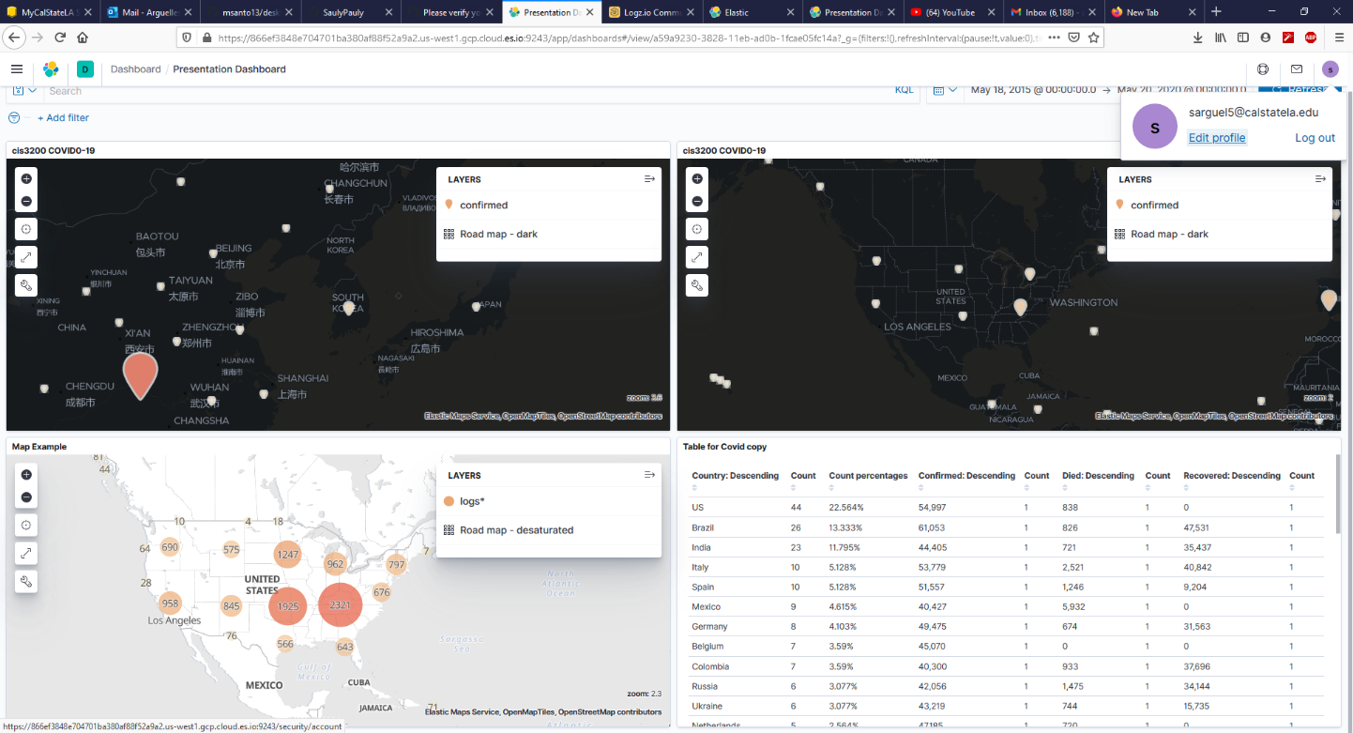

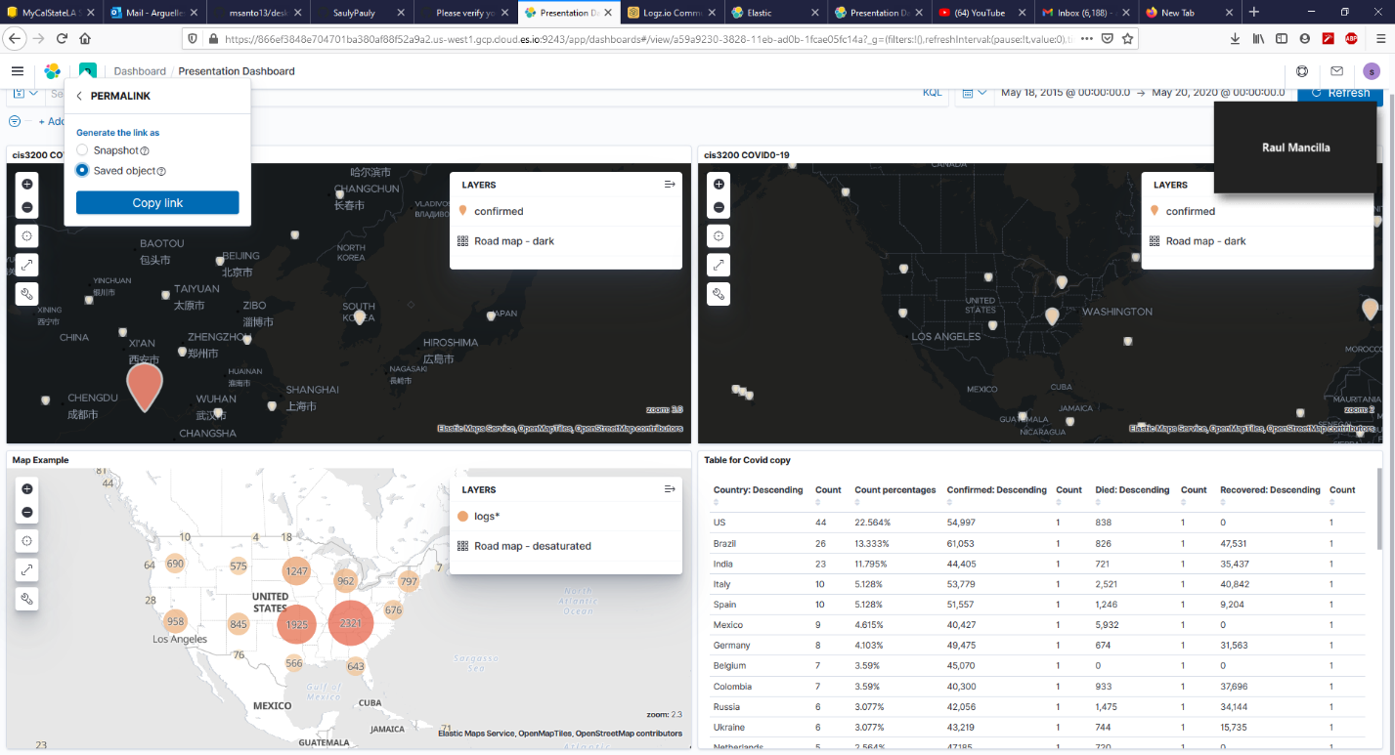

https://866ef3848e704701ba380af88f52a9a2.us-west1.gcp.cloud.es.io:9243/app/dashboards#/view/a59a9230-3828-11eb-ad0b-1fcae05fc14a?_g=(filters%3A!()%2CrefreshInterval%3A(pause%3A!t%2Cvalue%3A0)%2Ctime%3A(from%3A'2015-05-18T07%3A00%3A00.000Z'%2Cto%3A'2020-05-20T07%3A00%3A00.000Z'))